 | International Congress  Motor Vehicles & Motors 2024  Kragujevac, Serbia  October 10th - 11th, 2024 | Motor Vehicles & Motors

MVM2024-NNN

Type the author’s name here (Author style)
Type the co-author’s name here (if any, Author style)

THE TITLE OF THE PAPER (Paper Title style)

ABSTRACT: Begin typing your abstract here using the Text body style. Abstract should not contain more than 200 words. It should provide essential information on your research.

KEYWORDS: keyword 1, keyword 2, keyword 3, keyword 4, keyword 5 (the Text body style)

INTRODUCTION
Text of the paper should be written in one column, using previously defined styles. To use the styles, select the text you wish to apply a style to, then, using the mouse, point to the style box on the toolbar. Click once on the downward pointing arrow to the right, and select the appropriate style.

The body of the paper is written using the Text body style. The first line of the paragraph is not indented. Live a blank line between the paragraphs. Do not leave a line of space above and below the headings.

MAIN HEADING 1
The main headings (including the INTRODUCTION) should be written using the Heading 1 style with capital letters. Do not leave a line of space above and below these headings. Main sections may have subsections with corresponding subheadings.

Sub-heading 1
This is an example of using the first level sub-headings using the Heading 2 style. Please use capital and small letters. Do not leave a line of space above and below these headings.

Sub-sub-heading 1
If you need sub-sub-headings, please use the Heading 3 style. Use capital and small letters. Do not leave a line of space above and below these headings.

MAIN HEADING 2
Here are some practical hints for using bulleted lists, equations, tables and figures in the text of the paper.

If you need to use an unordered list using bullets, please use the Unordered list style:
- This is an unordered list using bullets.
- This is the second item in the list.
- This is the third item in the list.

If you need to use an ordered list using bullets, please use the Ordered list style:
- This is an ordered list, using numbers.
- This is the second item in the list.
- This is the third item in the list.

Equations should be written using the Equation editor, according to the following style, centred at the left column of the table. The right column of the table contains (centred) the number of the equation in the brackets. The applied table has no visible cell borders. Leave a blank line before and after the table containing the equation:

(1)

All equations must be numbered consecutively:

(2)

Tables should be centred. The title of the Table is centred and written just above the table, using the Table name style. Tables are numbered consecutively.

Table 1 Type the table title here (Table title text + style)

All illustrations, photos, graphics, etc. must be embedded as Figures into the document. Separate graphic files are not accepted. Line art must be professionally drawn and photos must be high quality with adequate contrast. Figures are inserted into the paper, centred with layout in line with text. The titles of the Figures should be written under the Figure, centred, using Figure title style. Please number figures consecutively. Live a blank line before the Figure and another one after the Figure title.

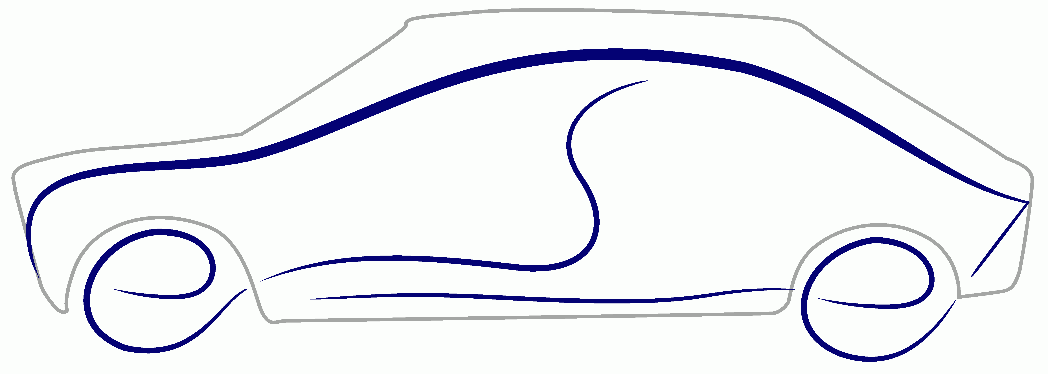
Figure 1 Type the title of the Figure here

CONCLUSIONS
Type your conclusions here.

ACKNOWLEDGMENTS
Here is the Acknowledgment section. This is an optional section.

REFERENCES
- References should be cited according to alphabetical order and prepared according to References style,
- The surname of the author, the first letter of name., co-author’s surname and the first letter of name.: “Reference title”, Journal (or Monograph, Congress, Proceedings, etc), Vol., No., Year of publishing, place, pages,
- Reference 3,
- Reference 4,
- Reference 5.

Author's name, affiliation, company, address, e-mail
Co-author's name, affiliation, company, address, e-mail

